Rotary Club of Kathmandu Mid-Town
Breakfast Chatter


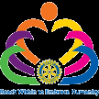

23 December 2011 The Weekly Bulletin of Rotary Club of Kathmandu Mid-Town Bc-12.23/011-12

District: 3292 Web: www.rotarymidtown.org.np Club Id : 26776

DECEMBER IS THE FAMILY MONTH
Rotarians, clubs, and districts worldwide are encouraged to demonstrate their commitment to family and community through projects, activities, and events in celebration of Family Month .

Wishing you all
Merry Christmas
2011
Click here ⇩

16 December, Friday:
Vice President Isabella conducted the regular Club meeting as President Som was slightly indisposed.
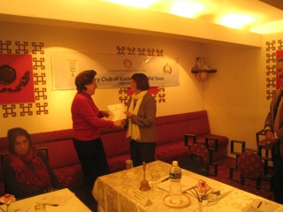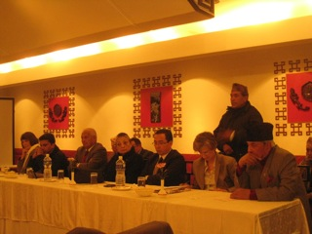
Vice President Isabella presenting a certificate RCC President Raghunath Thapa reporting on
of recognition to Guest Speaker, Carol Vernon the follow up completed projects in Lele. 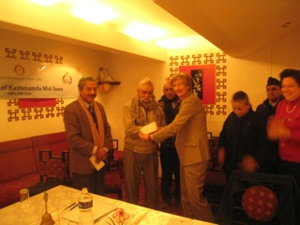 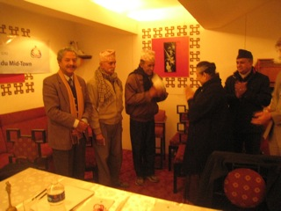
HE Rtn Verena handing over cheque of PP Ambica handing over another cheque of
Rs. 423, 400 to Rishi Bogote for the Gorkha Rs. 423, 400 to Damar B Basnet for the Lamjung
portion of GCS project. portion of GCS project.

18 December, Sunday:
One computer with accessories (made available by PP RR Shrestha) was handed over to Prakash Shrestha, Chairperson of Yuba Apaang Sangathan Nepal (Differently Able Youth Organisation-Nepal)at a small program organized at its office in Jorpati on Sunday, 18 Dec 2011. Rotarians from Kathmandu Mid-Town – PP Arun M Sherchan, PN Saroj Shrestha and PP RR Shrestha – were present at the program. The Organization, established in 2065 by a group of disable youth to address the causes of disabled, organizes programs for em-powering disable youth including computer training.
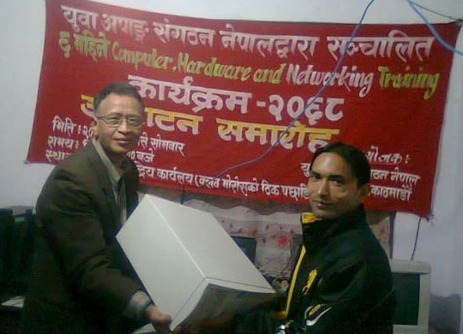
Rtn RR handing over the computer to Prakash Shrestha

Weekly Meetings and Programs :
Date | Program/Speaker | Program/Topics of Presentation
23 December 2011 | Thailand's Ambassador Maris Sangiampongsa | Lessons from Thailand's Rapid Socio-economic Development
30 December 2011 | Steven Dawa Sherpa | Great Himalayan Trek

23 December, Friday:
HE Maris Sangiampongsa, Thailand’s Ambassador to Nepal will be our Guest Speaker for the day and will be sharing his opinions on different aspects of socio-economic development in Thailand.

22 December, Thursday:
Sixth Board meeting of the Club is scheduled to be held on 22nd Dec, Thursday, at 17:30 hrs.
Venue: Tukche Thakali Kitchen, Durbar-marg
Host: PP Arun M Sherchan, Chairperson, Service Projects Committee

World most expensive cow !
Missy, a 3 year old black and white Holsten cow holds the record for the most expensive cow ever sold on the market. Winning the title for Grand Champion of the 2009 Western Fall National Show and being one of the best show cows in North America made it a target for buyers. Missy was sold for $1.2 mil in Ontario, Canada in Nov 2009.
Tibetan Mastiff, most expensive dog !
Holding the record for the most expensive dog ever purchased, Yangtze River Number Two is a black mastiff standing approximately 31 inches tall. The dog was purchased for $582,000 by a young millionaire known as Mrs Wang. When purchased at 18 months old, the black mastiff arrived in style, approaching her house in a 30 car motorcade.
Source: The Himalayan Times

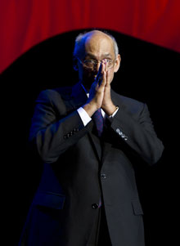
The family is where everything begins. It is where life begins, it is where our day begins, and it is
where our Rotary service must begin. Because it is the family, and not the individual, that is the
building block of the community – and of Rotary.
RI President Kalyan Banerjee

On Lighter Side :
Shopping bags! They may be useful in your e-shoppings!
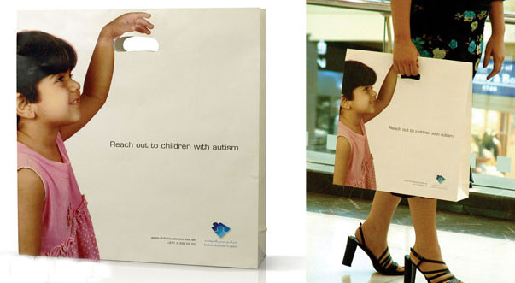

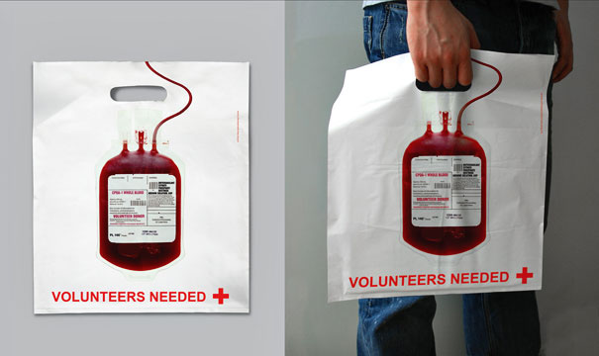

Please send project/activity information, suggestions and photos etc to :
BC Editor: RR Shrestha email: rryes@wlink.com.np

23 December 2011 The Weekly Bulletin of Rotary Club of Kathmandu Mid-Town bc-12.23/011-12

